**Lab sheet 2(Report requires both queries and screenshots)**

**Name:** J Viswaksena **Roll No:** AM.EN. U4AIE21035

**Part I**

**Question-1**

Run the below code on mongo console. It will insert 5 documents, which will serve as sample data for the next steps.

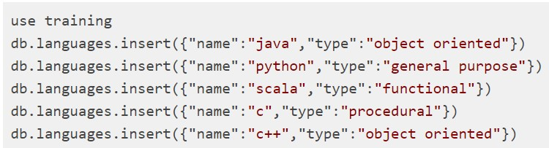

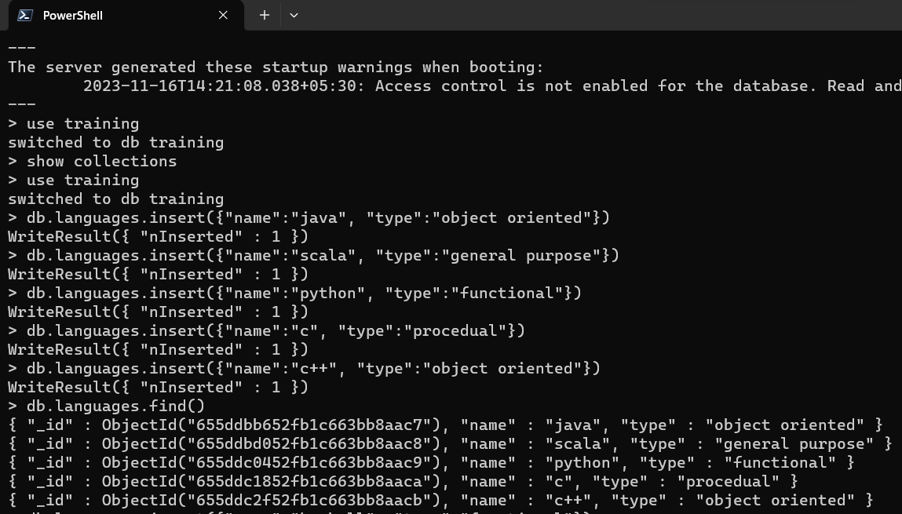

Q1) Insert an entry for 'Haskell' programming language which is of type 'functional .

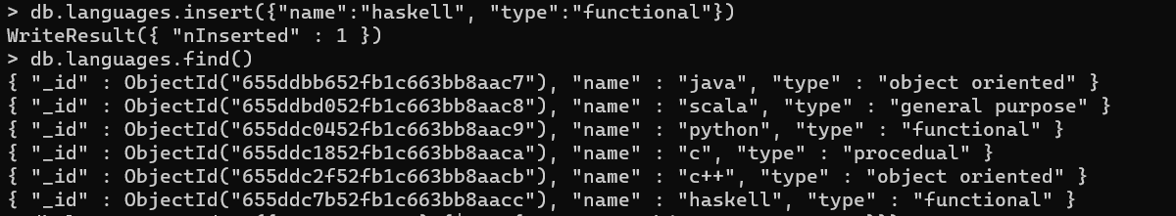

Q2) Query for all functional languages.

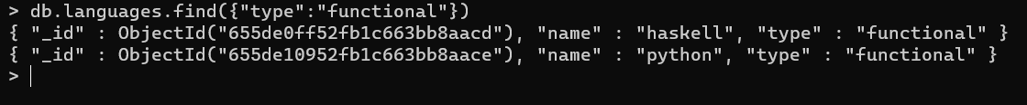

Q3) Add 'Bjarne Stroustrup' as creator for c++.

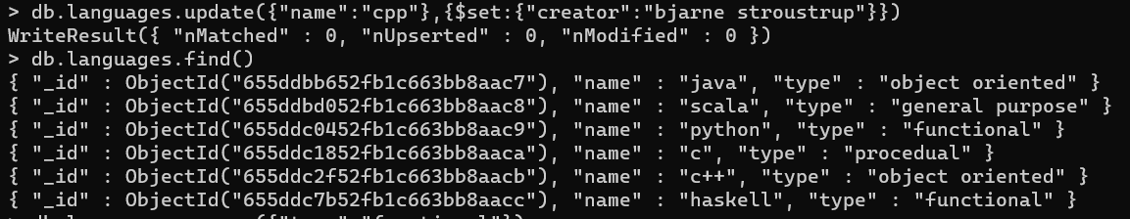

Q4) Delete all functional programming languages.

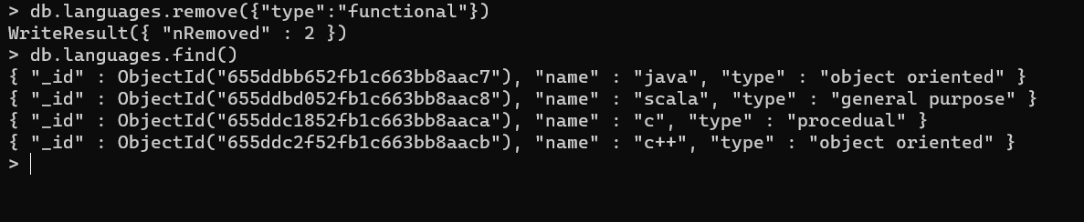

**Part II**

Write a Python program that can:

* connect to the mongodb server.
* select a database named **training**.
* select a collection named **mongodb_glossary**.
* insert the following documents into the collection **mongodb_glossary**.

{"database":"a database contains collections"}

{"collection":"a collection stores the documents"}

{"document":"a document contains the data in the form or key value pairs."}

* query and print all the documents in the **training** database and **mongodb_glossary** collection.
* close the connection to the server.

**Solution:** https://cf-courses-data.s3.us.cloud-object-storage.appdomain.cloud/IBMDB0151EN-SkillsNetwork/labs/MongoDB/Lab%20%20Accessing%20MongoDB%20using%20Python.md.html

**Python Code:**

from pymongo import MongoClient  
uri = "mongodb://127.0.0.1:27017/"  
client = MongoClient(uri)  
db = client.training  
collection = db.mongodb_glossary  
documents_to_insert = [  
{"database": "a database contains collections"},  
{"collection": "a collection stores the documents"},  
{"document": "a document contains the data in the form of key-value pairs."},  
]  
collection.insert_many(documents_to_insert)  
documents_all = collection.find()  
for document in documents_all:  
 print(document)  
client.close()

